Spring 2021: Time Series Midterm

IMPORTANT: By taking and submitting this exam, you are promising on your honor that you did not communicate about this test with anyone that could have helped on this test (except for Bivin Sadler) from Wed Noon to Sat 11:59pm. Please simply put your initials here to verify that this statement was both read and agreed to: ____

Thank you! Now rock this test!

*Note: Any code needed in any of the following problems should be either provided in line with the solution or in an appendix at the end.*

Questions 1 – 10: True or False or Short Answer (2pts each)

1. True or False: In an AR(2), if $ϕ_{1}>1$ then the model is non-stationary.
2. True or False: An AR(1) can have a peak in the spectral density at 0 *AND* .5.
3. True or False: An AR(2) can have a peak in the spectral density at 0 *AND* .5.
4. True or False: An AR(3) can have a peak in the spectral density at 0 *AND* .5.
5. True or False: An AR(2) can have a single peak in the spectral density at 0.
6. True or False: An AR(3) can have a single peak in the spectral density at .5.
7. True or False: All invertible models are stationary.
8. True or False: If a root of the characteristic equation of the AR part of a model is 1 then the model is stationary.
9. True or False: If the series is 20 observations long, you will have 19 pairs of observations to calculate ${\hat{γ}}_{19}$ .
10. Who was Dr. Woodward’s collaborator with respect to his model of the airline data?

Dr. Buddy Gray

1. Consider the model: $Xt- 1.2X_{t-1}+.9X_{t-2}=a_{t}-.3a_{t-1}+1.1a_{t-2}+{.5a}_{t-3}$
2. Write this model using backshift notation. (2 pts)
$$(1-1.2B+.9B^{2})Xt=(1-.3B+1.1B^{2}+.5B^{3})a_{t}$$

3. What is the characteristic equation with respect to the AR side of this model? (3 pts)
$$1-1.2z+.9z^{2}=0$$

4. Find the roots of this equation using the quadratic equation. You should show every step. You may check your answer with tswge however output from R should not be a part of the solution given below. (3 pts)
$$\frac{1.2±\sqrt{{1.2}^{2}-4(.9)(1)}}{2(.9)}=\frac{1.2±\sqrt{1.44-3.60}}{1.8}=.6667±.8165i$$

5. Is this model a stationary or non-stationary model? Why? (2 pts)

The modulus of this complex number is: $\sqrt{{.6667}^{2}+{.8165}^{2}}=1.054$

Since the modulus of the root is outside the unit circle, we know from theorem 3.2 that the model is stationary.

1. Is this model invertible or non-invertible? Why? At least half of this question is graded on the quality and completeness of your answer to the “Why?”. Using tswge here is ok if necessary. (3 pts)

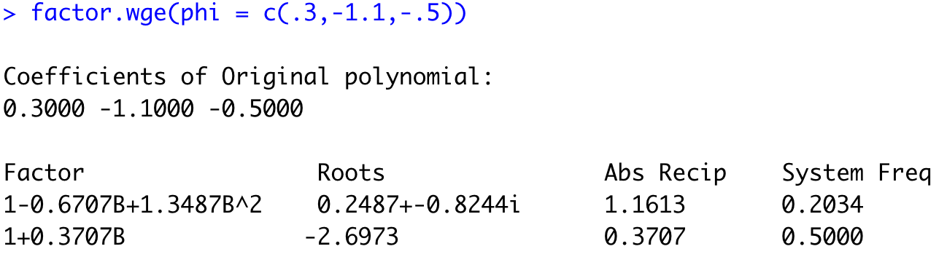

This model is **non-invertible** as It has a root that is inside the unit circle.

1. Does this model possess any periodic behavior? If so, thoroughly describe this behavior and your evidence of it. (2pts)

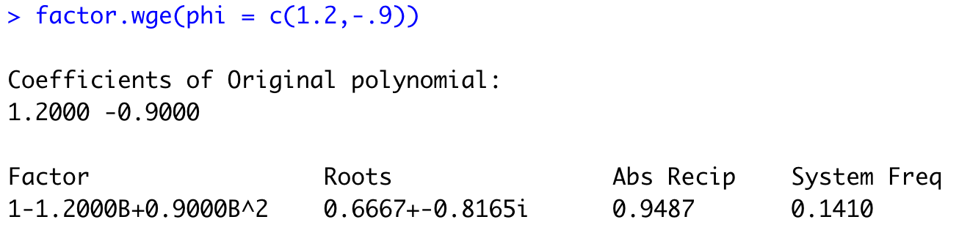

This model possesses fairly strong periodic behavior with a period of 1/.1410 = 7.1 $≈$ 7

1. Write this model as a GLP (just out to 5 terms.) (2pts)



$$Xt= a_{t}+.9a_{t-1}+1.28a_{t-2}+1.226a_{t-3}+.3192a_{t-4}$$

1. Assume the data is in an object called “data” and one of the filters given below was applied to the data. Given the Before and After spectral densities, what type of filter was applied? (2 pt)

|  |  |
| --- | --- |
| Before the Filter | After the Filter |
|  |  |

1. filter(data, rep(1,7)/7)
2. artrans.wge(data,1)
3. butterworth.wge(data, type = "pass", cutoff = c(.2,.4))
4. none are consistent with the spectral densities
5. On a separate sheet of paper, draw a representation of a spectral density of a data set that wanders and has period of 5. Answers will vary, we are just looking for a spectral density that would reflect these and only these behaviors. Simply take a picture of your hand-drawn and fully labeled spectral density and paste it below. (3 pts)

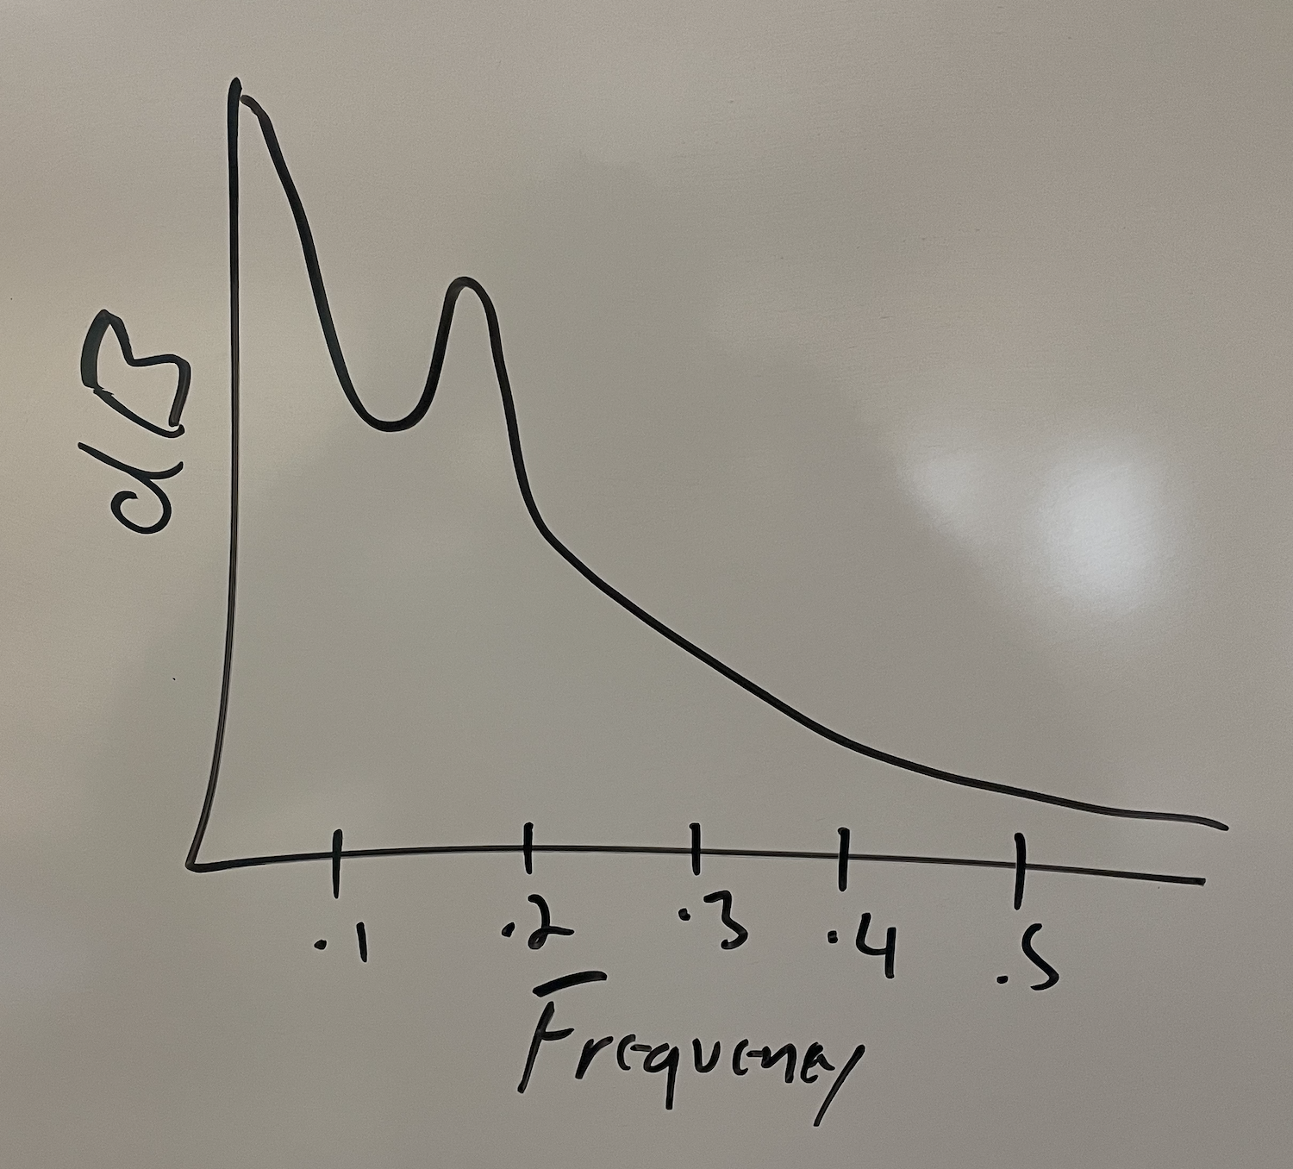

1. Assume you are forecasting with the model $\left(1-.8B\right)X_{t}=a_{t} { σ}_{a}^{2}=4.$
   1. Find the first 5 psi weights by hand using long division. Show the long division calculation. You can do this on a sheet of paper and paste a pic here or you can use Microsoft equation or another equation editor. (I would just do it by hand and paste a pic.) (2 pts)

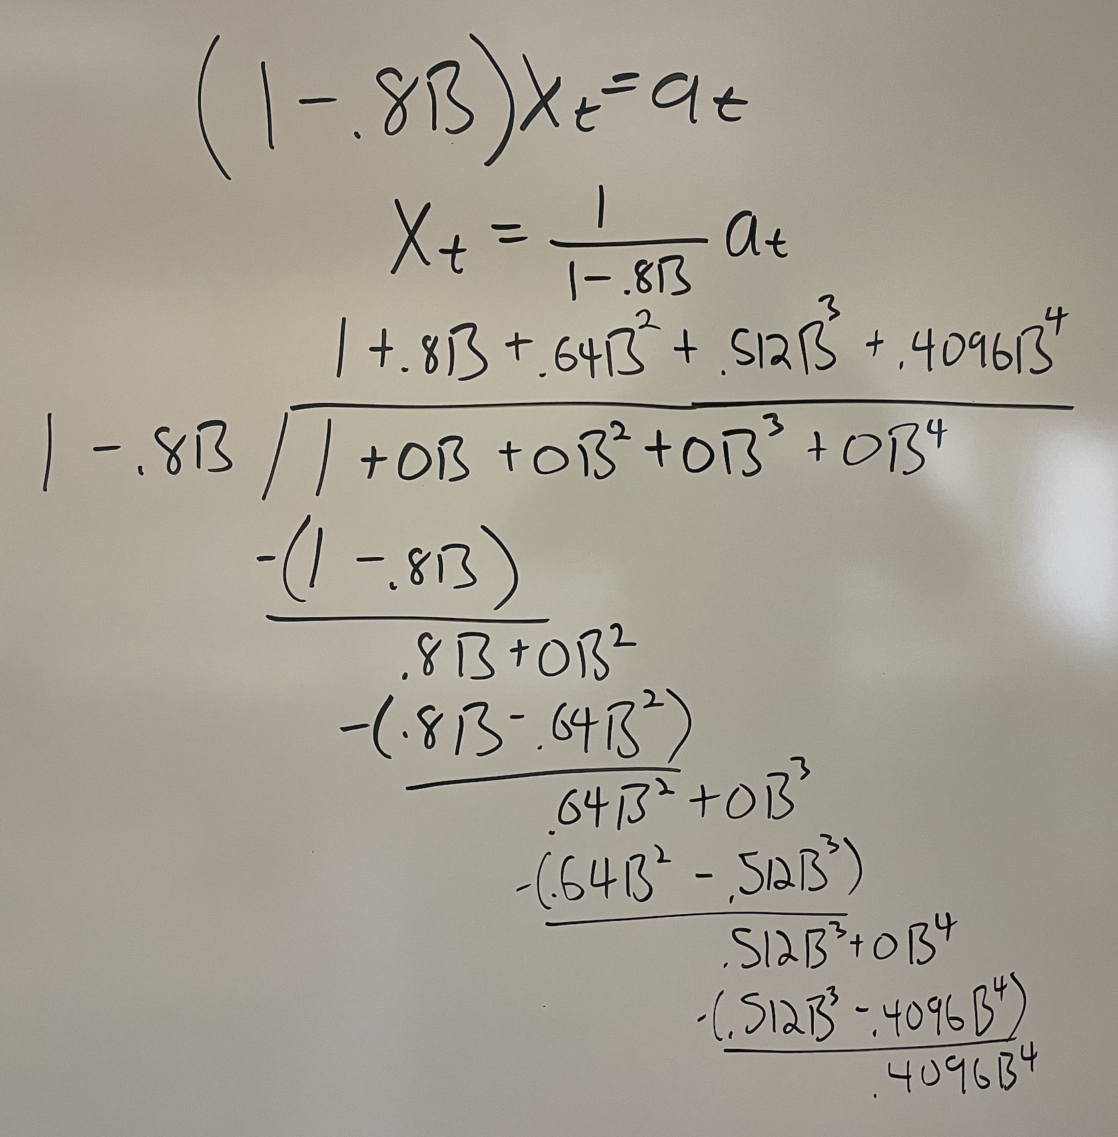

* 1. Assume you have a series that is 105 observation long. Show your work in finding the margin of error for the prediction interval for the forecast of ${\hat{X}}_{105}\left(3\right)$ . (3 pts)

$$MOE=1.96 σ_{a}{\left(\sum_{k=0}^{l-1}{ψ_{k}^{2}}\right)}^{1/2}$$

$1.96*2*\sqrt{1+{.8}^{2}+{.64}^{2}}$ =5.61

Match the ACFs in the first column with the Spectral Densities in the second column. (2 pts each)

|  |  |
| --- | --- |
|  |  |
|  |  |
|  |  |
|  |  |
|  |  |

15.__A 16. _B 17. _C 18. _D 19. _E

Match the realization in the first column with the acf or spectral density in the right column. (2 pts each)

|  |  |
| --- | --- |
|  |  |
|  |  |
|  |  |
|  |  |
|  |  |

20.__A 21. _B 22. _C 23. _D 24. E

Match the forecast to the model (note that the sample mean of the series is 579.): (3 pts each)

|  |  |  |  |
| --- | --- | --- | --- |
| 25. | 26. | 27. | 28. |

|  |  |
| --- | --- |
| 1. a 2. e 3. b 4. d | * 1. Airline Model   2. φ(Β)(1-B)Xt = θ(Β)at   3. ΑR(2) Complex Roots   4. AR(2) Real Roots   5. φ(Β)(1-Bs)Xt = θ(Β)at   6. (1-B)Xt = at |

1. In base R there is a dataset called **USAccDeaths** that provides the monthly number of accidental deaths in the US from 1973 to 1978.
2. Provide a plot, acf and spectral density of the data. (2 pts)



1. Comment on the stationarity of the data. Address each of the three conditions. This question will be graded on thoroughness of the response to each condition; please provide supporting evidence and explanation where necessary. Note: “thoroughness” does not necessarily mean length. (3 pts)

Condition 1: There is strong evidence of non-stationary periodic behavior with a period of 12. This is supported both with domain knowledge as it is intuitive that deaths would be higher at some times of the year that others and by the spectral density with a substantial peak at .083 (1/12).

Condition 2: It is tough to assess condition 2 as we only have one realization although I think you could make a case either way. I will say that, by looking at the 6 years of data we have, the there isn’t a lot of evidence of differing variance. The peaks wander about as much as the troughs. This of course is very speculative.

Condition 3: There is not sufficient evidence to suggest the autocovariance structure is different depending where you are in time. As an incomplete proxy of this condition, we see below that the acfs of the first and second half of the data nearly look identical.



1. Consider the three models below.
 $\left(1-B^{12}\right)\left(1- .93B\right)X_{t}=\left(1-.42B\right)a_{t}$

 $\left(1+.03B-.63B^{2}+.053B^{3}+.41B^{4}\right)X_{t}=\left(1-.89B\right)a_{t}$

 $\left(1-B^{12}\right)(1-B)X_{t}={(1-.53B)a}_{t}$

1. Identify the general class of each model. That is, identify them as AR(p), MA(q), ARMA(p,q), ARIMA(p,d,q) s, and be sure and specify the p,d,q and s when appropriate. (2 pts)
   2. For each model, comment on whether it is stationary or non-stationary? (2 pt)
   3. Find the ASE for each model in forecasting a horizon of 12. (2 pts)
   4. Find the ASE for each model in forecasting a horizon of 2. (2 pts)
   5. Which model do you feel is more useful in predicting “long term” horizons (one year ahead?) Why? (2 pts)
   6. Which model do you feel is more useful in predicting “short term” horizons (two months ahead?) Why? (2 pts)
   7. Now use each model to forecast the **next** 12 months and provide a plot of these forecasts. (3 pts) (BONUS 1 pt: Visualization!). You can earn an extra point here by creating a plot where the forecasts are a different color from the series.
   8. I. ARIMA(1,0,1) s = 12

II. ARIMA(4,0,1) or ARMA(4,1)

III. ARIMA(0,1,1) s = 12

* 1. I. Non stationary: (1-B12) (Roots are on the unit circle.)

II. Stationary, all roots are outside the unit circle (abs reciprocals are less than 1.).

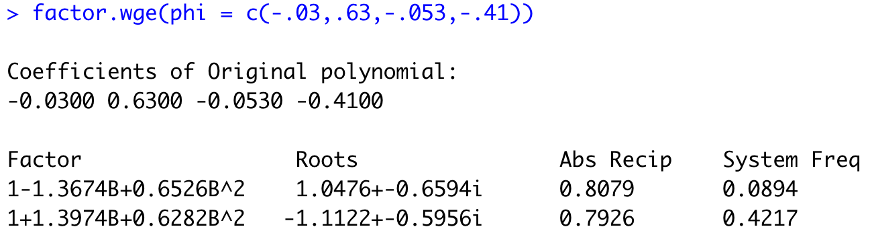

III. Non Stationary: (1-B12)(1-B) (Roots are on the unit circle.)

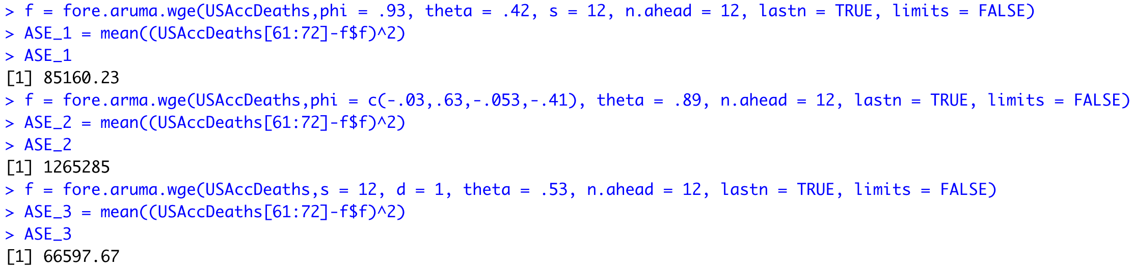

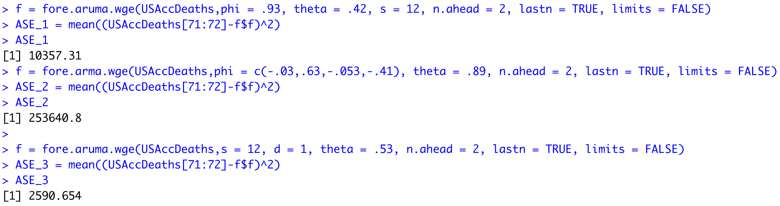

* 1. Based on the ASE the airline model (model III) is the most useful for long term (12 month) forecasts with an ASE of 66597.67.
  2. Based on the ASE the airline model (model III) is the most useful for short term (2 month) forecasts with an ASE of 2590.654.
  3. *I.*

*f1 = fore.aruma.wge(USAccDeaths,phi = .93, theta = .42, s = 12, n.ahead = 12, lastn = FALSE, limits = FALSE)*

*plot(as.numeric(USAccDeaths), type = "l", xlim = c(1,84))*

*lines(seq(73,84,1),f1[[1]], col = "red")*

**

*II.*

*f2 = fore.arma.wge(USAccDeaths,phi = c(-.03,.63,-.053,-.41), theta = .89, n.ahead = 12, lastn = FALSE, limits = FALSE)*

*plot(as.numeric(USAccDeaths), type = "l", xlim = c(1,84))*

*lines(seq(73,84,1),f2[[1]], col = "red")*

**

*III.* *f3 = fore.aruma.wge(USAccDeaths,s = 12, d = 1, theta = .53, n.ahead = 12, lastn = FALSE, limits = FALSE)*

*plot(as.numeric(USAccDeaths), type = "l", xlim = c(1,84))*

*lines(seq(73,84,1),f3[[1]], col = "red")*

**

Bonus:

1. (2 pts) ARMA(p,q) models can be written as an infinite order AR(p) or an infinite order MA(q). Consider the model: $Xt- 1.2X_{t-1}+.9X_{t-2}=a_{t}-.3a_{t-1}+1.1a_{t-2}+{.5a}_{t-3}$. Write the first 5 terms of the AR(p) representation of this model.
2. (1 pts) Rolling Window ASE